

MULTIMEDIA UNIVERSITY OF KENYA

FACULTY OF COMPUTING AND INFORMATION TECHNOLOGY

BACHELOR OF SCIENCE IN INFORMATION TECHNOLOGY

PROJECT DOCUMENTATION

EXPONENT FUTURE

BY

SOLOMON NDUNG’U

CIT-221-011/2015

SUPERVISOR: MADAM ELIZABETH MULI

AUGUST, 2018

*Submitted in partial fulfilment of the requirements of Third Year Bachelor of Science in Information Technology*

The project is a requirement by the Multimedia University of Kenya for all students taking a course in Computing and Information Technology. The project is meant to help the students in practicing what we have learned in class and also help us come up with other creative and innovative ideas.

**MONTH/YEAR:**

04/07/2018

**List of Abbreviations**

PIN - Personal Identification Number

Bonds - funds given to governments or their agents as loans from public or individuals.

Mutual Funds - bundle together securities to offer investors diversified [portfolios](https://www.investopedia.com/terms/p/portfolio.asp" \t "C:/Users/Solo%20Ndung'u/Downloads/_blank).

Stocks - share of capital of a company.

Portfolio -  is a grouping of financial assets such as stocks, bonds and cash equivalents, as well as their funds counterparts, including mutual, exchange-traded and closed funds. Portfolios are held directly by investors and/or managed by financial professionals.

ETF - Exchange Traded Fund: is a type of fund that owns assets like stocks, foreign currency and divides ownership of those assets into shares.

App - application

robo-advisors - represent online services for portfolio management. Robo-advisors can automatically rebalance portfolios when necessary.

MYSQL – Microsoft Structured Query Language

PHP: - Hypertext Pre-processor

GDP – Gross Domestic Product

**List of Figures**

Figure a

Figure b

**List of Tables**

Table 1

# 

[Declaration Page 8](#_Toc16148)

[Abstract 9](#_Toc24112)

[CHAPTER ONE : INTRODUCTION 10](#_Toc8950)

[1.1 Introduction and Background of Study 10](#_Toc29959)

[1.2 Problem Statement 12](#_Toc4506)

[1.3 Objectives of the Study 13](#_Toc16442)

[1.3.1 Project Goal 13](#_Toc12606)

[1.3.2 General Objectives 13](#_Toc2488)

[1.3.3 Specific Objectives 13](#_Toc22308)

[1.4 Research Questions 14](#_Toc7684)

[1.5 Justification of the study 14](#_Toc24807)

[1.6 Scope 16](#_Toc8936)

[1.7 Limitations of the proposed system 17](#_Toc2396)

[1.8 Student Personal Statement 18](#_Toc11083)

[CHAPTER TWO : LITERATURE REVIEW 19](#_Toc30092)

[2.1 Introduction 19](#_Toc14031)

[2.2 Reviewed Similar Systems 20](#_Toc16998)

[2.2.1 Features common to all web and mobile based systems 21](#_Toc25390)

[2.2.2 Challenges from the reviewed web and mobile based system 22](#_Toc24859)

[2.2.3 The Proposed Solution 22](#_Toc1458)

[CHAPTER THREE : METHODOLOGY 24](#_Toc16195)

[3.1 Introduction 24](#_Toc21821)

[3.2 The Methodology 24](#_Toc24889)

[V model 24](#_Toc20920)

[Verification Phases 25](#_Toc2132)

[Coding Phase 27](#_Toc15337)

[Validation Phases 27](#_Toc3042)

[3.3 Sources of Data 29](#_Toc18682)

[3.4 Data Collection Methods 29](#_Toc793)

[3.5 Required resources 30](#_Toc22328)

[3.6 The Project Schedule 31](#_Toc3920)

[3.7 The Budget 32](#_Toc21977)

[CHAPTER FOUR: SYSTEM ANALYSIS AND DESIGN 33](#_Toc20799)

[4.1 Introduction 33](#_Toc24510)

[4.2 Business Requirement Analysis 33](#_Toc10527)

[4.2.1 Functional requirements 33](#_Toc18836)

[4.2.2 Operational Requirements 36](#_Toc8410)

[4.2.3 Technical Requirements 37](#_Toc9672)

[4.2.4 Transitional Requirements 37](#_Toc6318)

[4.3 System Design 38](#_Toc5402)

[4.3.1 Design Objectives 38](#_Toc20975)

[4.3.2 Logical Design 38](#_Toc12506)

[4.4 Module Design 44](#_Toc4296)

[4.5 Coding Phase 45](#_Toc1052)

[4.5.1 HTML 45](#_Toc5429)

[4.5.2 CSS 46](#_Toc29532)

[4.5.3 Bootstrap 46](#_Toc27780)

[4.5.4 Javascript 46](#_Toc11879)

[4.5.5 Nodejs 46](#_Toc26652)

[4.5.6 MongoDB 46](#_Toc26256)

[4.5.7 Implementation 46](#_Toc11113)

[CHAPTER FIVE: CONCLUSIONS AND RECOMMENDATIONS 47](#_Toc4977)

[5.1 Degree of Success, Learning Experience 47](#_Toc4623)

[5.2 Conclusion 47](#_Toc8903)

[5.3 Limitations 48](#_Toc30934)

[5.4 Recommendations and future work 48](#_Toc5169)

[REFERENCES 49](#_Toc1782)

# Declaration Page

I hereby declare that this Project Report is my original work and has not been published and/or submitted for any other degree award to any other University before.

Signed: ..................................... Date: ......................................................…

# 

# Abstract

# Exponent Future is a mobile based application platform where users are able to invest in Exchange Traded Funds, stocks, bonds and mutual funds. This is enabled by a friendly user interface and also a column of educating investors who are beginners. The column contains articles that talk of various types of investment strategies and how to invest with the little cash or the much cash one may have. It allows commission-free trades but up to a certain limit, and also offers extended trade hours. It encourages the market, mostly the Kenyan market of investing for the future.

# 

# CHAPTER ONE : INTRODUCTION

## 1.1 Introduction and Background of Study

Kenya is one of the ever-growing country in terms of economy. Due to advancement in education, more and more young people are getting access to money but really don’t know the right way of spending it maximally. Nairobi Security Exchange is a great platform of investment of companies’ stock but costs of transactions and commissions discourage most from venturing into it. In addition, some young people are unaware of the way of investing or are even discouraged by the many protocols involved in putting their money broker accounts for them to be managed by the brokers themselves.

Thus, Exponent Future is a mobile application that offers solution to the above problem. It allows users to open an account and link their bank accounts to the Exponent Future’s account. It may require a minimum deposit but it’s affordable, and when one uses the account for investment; no minimum balance is required. After a few days of security check and clearance( including bio-metrics, PIN, retina and secret information for emergency purposes) it allows one to start trading.

It allows one to press a menu that brings out columns of different categories of stock investment. When one clicks on stocks, it brings the different sub-categories of sectors of companies in the market,e.g, agricultural companies, business companies, technological companies, industrial companies etc. When one clicks technological companies, they then find the companies they are targeting to buy shares from.

One may also keep a watch-list of the companies they are targeting or wanting to invest in. It may also bring notifications in one’s smart phone telling the user of the great market changes that are favorable for their investment.

It also allows one to be keeping tabs on their deposits. The user is given a management plan that allows them to be saving the targeted money to buy a targeted number of shares from a particular company. Thus, it encourages both saving and wise management of income. Thus, the user has control of his money and can monitor it.

The application will be of great importance because it has a **number of advantages** as listed below:

1. It is well-categorized, thus provides a vast scope of investment options for both beginners and advanced investors.
2. It allows one to monitor their money, thus management of savings allows one to be wise in spending and allowing for its growth.
3. It is a commission-free trading application. Thus it is highly affordable for the most Kenyan population who are being exposed to the stock market.
4. It has security features that protects one from fraud. Bio metrics and retina. Also companies of financial protection will also be involved before approval of the application to the market.
5. The application is responsive for it fetches and allows user to interact with real-time data. Also statistical graphs allow one to make wise decisions.
6. The higher and more loyal one becomes to investment, the greater the chances of one insuring their shares at a lower fee (when hacking or fraud occurs).
7. Also a feature of buying on margin (borrowing cash to top up shares that one may not afford at that time).
8. It’s a bit complex but attractive. The many columns may be a bit tardy, but its features make it appealing.

## 1.2 Problem Statement

Exponential Future is a mobile application where users will be able to see their money grow and also ensure that their future is bright due to the wise decisions made in utilizing their money well.

The application will be used in smart-phones and tablets.

Traditionally, most investors approach other companies so that they can buy stocks and bonds. This is costly for people who are for the first time becoming familiar with the stock exchange market.

It also allows users to put their money that may not be in use to good use in the stock market.

Also there will be confidentiality in trading.

## 1.3 Objectives of the Study

### 1.3.1 Project Goal

To come up with an effective mobile application which guarantees clients easy to use and access to stock market.

### 1.3.2 General Objectives

To promote education on investment and allow growth of users money.

### 1.3.3 Specific Objectives

These are the objective of the study :

1. To guarantee a user-friendly design.
2. To guarantee exposure to investment opportunities in the stock market.
3. Also for learning of investment terminologies and know how to use them to make wise decisions.
4. Eliminate fee costs involved in trading via companies.

## 1.4 Research Questions

Here is the key research questions for this study:

1. How does the design guarantee user-friendliness?
2. Is the system responsive to end-users’ devices of different sizes?
3. How will the users follow up on the current trends in stock market and understand its dynamics?
4. How will transaction and commission costs be reduced (or eliminated) by the application?
5. How will the application ensure that users can recommend the app to their friends?
6. How will underage users be treated? Will they be given the same privilege as right-age users?
7. How will the app developers earn their money?

## 1.5 Justification of the study

Exponential Future is a mobile application intended for investment of income in companies: Public Limited Liability Companies, Parastatals, private companies (who mostly need few selected share-holders). The application will clearly help them show and inform clients about their companies success and why the clients would benefit in investing in their companies. Also will help improve the economy of the country for investment allows pull of resources so as to advance more in technology.

The application will also allow clients inquire from the trusted company leading the investment app about investing in case they may not fully understand the scope of investment. The company (e.g, Nett Consultants) will have agents who will be acting as customer care who will be helping clients understand about investment and using the app optimally so as to maximize productivity of their money. Although it may be far-fetched, robo-advisors will be integrated with the app in giving extensive advice on how to invest (in the future or in version 2.0).

The application will solve some challenges as depicted below:

1. It will allow users to interact with the stock market at their own comfort. Be it at home, at work or even in the hospital they will have access to the stock market via their phones.
2. Will allow for users to interact with agents that will help them in knowing about investment. Although, if they use this service excessively, it may come at a fee.
3. Soon it will allow access to robo-advisors who will enable users to know how to manage their finances well and invest wisely mostly at no cost.
4. A watch list will allow one to keep tabs on his favorite company. Notifications will allow one to be aware of the best trades happening thus don’t miss out on opportunities.
5. A target plan will allow one to be saving more money so as to reach his/her investment goals and allow growth in income.
6. Application will allow even the non-business groups of people to invest in the economy.
7. Minors will also be allowed to invest but under certain supervision if they are handling large sums of money.

## 1.6 Scope

Internet access is becoming cheaper and more affordable by the day. Also, smart-phones are improving in terms of storage capacities and performance by the day. The smart phones are also becoming cheaper. Thus, with the youth having the tendency of being close to their smart phones, the app is a great platform because smart phones are being used by most people. The app can be accessed by lots of people.

Also the app will allow companies’ progress to be monitored when users are clicking on the details sub-section to see progress of company, major changes in company or even news about the company.

The companies shares will be accessed via the app.

## 1.7 Limitations of the proposed system

The frequent update of the statistics may consume a lot of bandwidth. Also, the various categories, investment types, management of finance and accessing sites detailing about a company may demand more memory than usual.

Agents may be expensive to consult, and robo-advisors may make it hard for the app to generate more money than it should for it is cheaper to consult a robo-advisor than a human agent.

Insurance and security coverage by Financial companies can delay release of the app due to various tests and approval.

Also various investment companies may oppose the app because it renders them almost useless when it comes to investing for their clients for the app enables the clients to invest for themselves.

**Solution to limitations**

The bandwidth problem will be checked and sorted as the app is improved with time.

The app will also be made lighter and friendly to memory as frequent updates of it are made.

Robo-advisors will make consulting cheaper and more efficient and accurate for they will be available 24/7.

Insurance and security coverage will be possible once rights of the app are made clear and further pushing by the company in charge of app is done.

Companies will have to go with the trend of business being done by computers and by the clients themselves.

## 1.8 Student Personal Statement

While I was in Primary and High School, I didn’t know where to take my money so as it may grow while I studied. I did little to manage my finances well and when I started managing my finances, it really demanded lots of patience for it was just there sitting around without earning any income.Right now I have less access to money than I had while I was in primary or High School. Thus, the app will solve lots of problem among the youth.

# CHAPTER TWO : LITERATURE REVIEW

## 2.1 Introduction

Kenya’s population is mainly composed of a young generation of youths and working adults. With the ever rising inflation in the country, savings and investment’s interest rates are positively affected thus urges people to invest and save more. However, not everyone is aware of the need or importance of these two. In addition, Nairobi Securities Exchange has been ever improving and offering a greater opportunity for investment and earning dividends. Thus, when one offers a platform for the youths to invest and access future benefits, Kenya’s economy will depict a positive trajectory in terms of improvement.

Kenya is termed as a hub for the East and Central Africa’s development, for it offers a port for easy trades that Uganda uses for its exports.In addition, multinational investors have picked Kenya as their central place for business ventures. The future is still promising in Kenya.

The NSE has been performing dismally for the last couple of quarters due to a myriad of reasons, some being a poorly performing economy, lack of investor confidence, lack of investor awareness for the local investor and too many profit warnings from the listed firms.

To many, this presents a bad omen, to me, this is the perfect time to enter into the market, when the bear is ruling and the bull is bleeding profusely. Yes, it will take time for the bull to heal and for the bear to be shown the down, which means, in between, is the perfect time to get in, get your front seat and wait for the wind to hit the sail and the NSE will soar.

Allowing the young generation to be aware of investment and about stocks and exchange traded funds will contribute capital to companies, allow ownership of assets by the person investing, allow for better utilization of resources and over the years will improve the standards of living among the youth that have been faithful with increasing their assets during the period.

Allowing Kenya to move from a low income economy to a middle and high income economy will improve the status of the country within the continent and also worldwide.

Because of the secondary market, private persons become securities owners directly or indirectly (with the help of investment banks and funds). Availability of a sufficient number of private investors allows the economy to function efficiently, drawing huge funds for vital tasks solution. That is what stock investing apps can do.

## 2.2 Reviewed Similar Systems

Some of the applications and web based system that have been developed in Kenya and also worldwide include:

1. Abacus (a data vendor of the Nairobi Securities Exchange. It also allows buying of stocks and unit trusts. It is a mobile application)
2. Robinhood (mobile application developed in the U.S. It is a stock broker app that enjoys commission-free trades)
3. Acorns (mobile application developed in the U.S. Allows asset management and goals of investment. Monitors money spending and can advice on retirement plans)
4. E\*Trade (is a web application and also a mobile application platform. Offers extensive trading, retirement benefits, research insights up-to-date market watch)

### 2.2.1 Features common to all web and mobile based systems

When comparing the above systems, they have some similarity as listed below:

1. Stock trading at minimum charges.
2. Data or statistics concerning the stock exchange and market trades.
3. Minimum deposits and no minimum cash to maintain in account.
4. Friendly User Interface.
5. Acceptable User Experience.
6. Tight security against fraud.

### 2.2.2 Challenges from the reviewed web and mobile based system

Abacus allows trading on the Kenyan market but it has a requirement of maintaining the account with a fee of Kes 1000 per month. That is expensive over the year for investing from a low income person who has just become aware about investments.

Robinhood only allows trading in stocks. Thus, little education and research insights is offered by the application. Also, Robinhood only allows investment in the U.S market. Thus, there is no reach of the app in other countries economy and more so in Kenya.

Acorns is one of the best apps in offering advice and financial management. Although, its access to the Kenyan market is limited. It is mainly used in the U.S.

E\*Trade is costly for beginners and low income earners. And its low tax benefits are only limited to the U.S residents.

### 2.2.3 The Proposed Solution

Following some of the problems listed in the above literature review, Exponential Future will improve new functions like:

1. Allow user to study the stock changes in the Kenyan market.
2. Allow users to read blogs about managing finances and various financial approaches (Education). Also a section of study will be there to allow awareness of the business world, the terminologies used in investment and smart ways of secure investment.
3. Ease of use of the app.
4. Extensive security against malicious transactions and fraud.
5. Robo-advisor (coming soon in an improved version)

# CHAPTER THREE : METHODOLOGY

## 3.1 Introduction

The proposed project is aimed at coming up with a mobile app that will enable users to start in investment of stocks and other funds. It will also allow blogs from sites like investopedia to be shared so as to increase knowledge of the person using the app. The so coming robo-advisor will enable the user track his spending patterns and advice on ways to enable a future of investment and increased income. The stocks data will be collected from the Nairobi Securities Exchange and bonds from government finance updates. Also the different investment companies will join up and improve strategies of investment and making the usage of the app as minimal in terms of cost as possible.

## 3.2 The Methodology

### V model

V- model means Verification and Validation model. Just like the waterfall model, the V-Shaped life cycle is a sequential path of execution of processes. Each phase must be completed before the next phase begins. Testing of the product is planned in parallel with a corresponding phase of development.

The V - model is SDLC model where execution of processes happens in a sequential manner in V-shape. It is also known as Verification and Validation model.

V - Model is an extension of the waterfall model and is based on association of a testing phase for each corresponding development stage. This means that for every single phase in the development cycle there is a directly associated testing phase. This is a highly disciplined model and next phase starts only after completion of the previous phase.

The below figure illustrates the different phases in V-Model of SDLC.

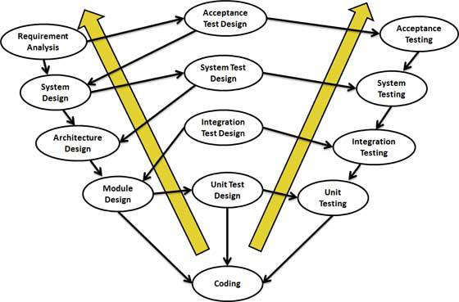

*Figure a*

Verification Phases

Following are the Verification phases in V-Model:

* **Business Requirement Analysis:** This is the first phase in the development cycle where the product requirements are understood from the customer perspective. This phase involves detailed communication with the customer to understand his expectations and exact requirement. This is a very important activity and need to be managed well, as most of the customers are not sure about what exactly they need. The acceptance test design planning is done at this stage as business requirements can be used as an input for acceptance testing.
* **System Design:** Once you have the clear and detailed product requirements, it’s time to design the complete system. System design would comprise of understanding and detailing the complete hardware and communication setup for the product under development. System test plan is developed based on the system design. Doing this at an earlier stage leaves more time for actual test execution later.
* **Architectural Design:** Architectural specifications are understood and designed in this phase. Usually more than one technical approach is proposed and based on the technical and financial feasibility the final decision is taken. System design is broken down further into modules taking up different functionality. This is also referred to as High Level Design (HLD).

The data transfer and communication between the internal modules and with the outside world (other systems) is clearly understood and defined in this stage. With this information, integration tests can be designed and documented during this stage.

* **Module Design:**In this phase the detailed internal design for all the system modules is specified, referred to as Low Level Design (LLD). It is important that the design is compatible with the other modules in the system architecture and the other external systems. Unit tests are an essential part of any development process and helps eliminate the maximum faults and errors at a very early stage. Unit tests can be designed at this stage based on the internal module designs.

Coding Phase

The actual coding of the system modules designed in the design phase is taken up in the Coding phase. The best suitable programming language is decided based on the system and architectural requirements. The coding is performed based on the coding guidelines and standards. The code goes through numerous code reviews and is optimized for best performance before the final build is checked into the repository.

Validation Phases

Following are the Validation phases in V-Model:

* **Unit Testing:** Unit tests designed in the module design phase are executed on the code during this validation phase. Unit testing is the testing at code level and helps eliminate bugs at an early stage, though all defects cannot be uncovered by unit testing.
* **Integration Testing:** Integration testing is associated with the architectural design phase. Integration tests are performed to test the coexistence and communication of the internal modules within the system.
* **System Testing**: System testing is directly associated with the System design phase. System tests check the entire system functionality and the communication of the system under development with external systems. Most of the software and hardware compatibility issues can be uncovered during system test execution.
* **Acceptance Testing:** Acceptance testing is associated with the business requirement analysis phase and involves testing the product in user environment. Acceptance tests uncover the compatibility issues with the other systems available in the user environment. It also discovers the non functional issues such as load and performance defects in the actual user environment.

**Advantages of V-model:**

* Simple and easy to use.
* Testing activities like planning, test designing happens well before coding. This saves a lot of time. Hence higher chance of success over the waterfall model.
* Proactive defect tracking – that is defects are found at early stage.
* Avoids the downward flow of the defects.
* Works well for small projects where requirements are easily understood

**Disadvantages of V-model:**

* • Very rigid and least flexible.
* • Software is developed during the implementation phase, so no early prototypes of the software are produced.
* • If any changes happen in midway, then the test documents along with requirement documents has to be updated.

**When to use the V-model:**

* • The V-shaped model should be used for small to medium sized projects where requirements are clearly defined and fixed.
* • The V-Shaped model should be chosen when ample technical resources are available with needed technical expertise.

## 3.3 Sources of Data

1. Brainstorming.
2. Observation in the organizations concerning users experience.
3. Research via the internet.

## 3.4 Data Collection Methods

1. **Observation** - information from observing helps me formulate decisions about giving priority to the features and operational functions that allow effective user experience.
2. **Interviews** - provide perspective of clients and investors experiences while engaging with the Exponent Future mobile application together with existing similar system.

## 3.5 Required resources

1. **Hardware Specifications**

16 GB internal memory

2 GB RAM

3G or 4G mobile phone

**ii. Software Specifications**

Android 5.0 and above or iOS or Windows for mobile phones.

For Desktop Computers and laptops: windows 7 or above, iOS of any version, Linux of any version, Debian of any version. They should have a browser installed so as to access the web application.

TOOLS FOR DEVELOPMENT:

Platform : mobile or smart-phone, computer or laptop

Language: Javascript

Back-end: nodejs(express), MongoDB or SQL

Editors:Sublime Text

SDK:node package manager

For Design: JavaScript, Python

Testing responsiveness:Android Studio, Chrome

TOOLS FOR DEPLOYMENT

Operating system:Windows 10, Ubuntu 16.4 LTS, 17.10 or Higher

Smart-phone/Tablet

Server:XAMPP

Anti-Virus:COMODO

Back-end:SQL or MongoDB and nodejs

## 3.6 The Project Schedule

Gantt chart shows an overview of when I am going to carry out the specific steps in our project from the ideation of the project to writing of final report.

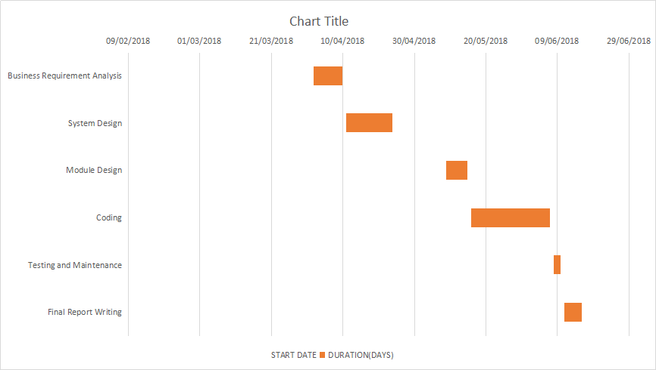

*Figure b*

## 3.7 The Budget

The proposal budget will enable me set the financial requirements for the whole project.

|  |  |
| --- | --- |
| ***ITEM*** | ***COST (Ksh)*** |
| Internet | 2000 |
| Domain Registration | 1500 |
| Miscellaneous expenses | 2500 |
| Testing environment | 1000 |
| **Total Cost** | **7000** |

*Table 1*

# CHAPTER FOUR: SYSTEM ANALYSIS AND DESIGN

## 4.1 Introduction

System design is the process of defining the architecture, modules, and detailing the complete hardware and communication setup for the product under development.

System text plan is developed based on the system design.

## 4.2 Business Requirement Analysis

Is the first phase where the product requirements are understood from the customer perspective. Involves detailed communication with the customer to understand his expectations and exact requirement.

To make analysis easier, the requirements are grouped into these four categories:

### 4.2.1 Functional requirements

These define how a product/service/solution should function from the end-user’s perspective. They describe the features and functions with which the end-user will interact directly.

* Includes data entered by the user,i.e; Name, email, Identification Card, Password.
* Navigation buttons being clicked at the home page so as to navigate the website:
  + Access button to show the sidebar; and in the sidebar:
    - the hide button to hide the sidebar,
    - the register button to move to the registration page,
    - login button to move to the login page,
    - the Stocks button to allow a logged in user to access the market stocks,
    - the Portfolio button to allow user to see his recently bought asset or accumulated asset,and;
    - the Learning button to allow user to go to the page and access the investing terms.
* In the home page, the user can scroll down and read the summary explaining the project.
* In the Register page, the user will enter details about themselves. It includes:
  + First and Second Name: Data Type; String,
  + National ID: Data Type; String,
  + Email: Data Type; String,
  + Password: Data Type; String,
  + Password\_repeat: Data Type; String.
    - The National ID is required so as to ensure the user is tracked or saved exclusively or uniquely to prevent collision of user details in case some users have the same name.
    - Electronic Mail(Email) is needed so as to update user of new services and products that may be introduced as time goes by.
    - Password to ensure user authentication or confidentiality.
    - Password\_repeat to make sure the user is consistent with their password entry and recalls his/her password.
* The register button will bring a success page saying that the user has registered successfully. If they haven’t put all the details, they will be redirected to the same page asking them to fill in the empty field.
* The Login page will allow the user to enter email and password so as to be recognized as persons that has already registered so as to go to the Stocks page.
* Successful login will bring a success page telling the user that they have logged in successfully. If the authentication fails, and the user is not recognized as having existed in the database; they are redirected to the same page and are asked to retry entry.
* Stocks page displays a small table containing details about a mentioned company and prices of shares.
  + The first column displays the company name.
  + The second column displays the company price per share.
  + There is a button beside the column row allowing a user to click on it and thus buy the share.
* The Portfolio page displays the users shares.
  + At the bottom of the Portfolio page there is a learning button that allows the user to click it and move to the learning page.
  + The learning page Contains a navigation bar that allows the user to click and thus change the content and display the changed content of the “pill” or the element clicked by the user.
  + The content explains about e.g stocks. There are links associated with certain words in the stocks paragraph that allows the user to click it and be directed to the page explaining the technical term used. Also there is a link below the page called “Further reading” allowing the user to be directed to a page that explains further about the topic being discussed.
* Each page contains a button at the top, allowing one to navigate back to the home page(register, login and learning page has this button), or navigate forward to the portfolio page(stocks page has this button) or learning page(portfolio page has this button).
* At the bottom of the register page, there is a link allowing the user to click and move to the login page if they already had registered previously.
* At the bottom of the register page, there is a link allowing the user to click and move to the register page if they hadn’t yet registered previously.

### 4.2.2 Operational Requirements

These define operations that must be carried out in the background to keep the product or process functioning over a period of time.

* I updated my Operating System to ensure designing and use of the system without any error from the operating system that could affect functionality of system.
* Updating my Operating system also ensures increased security of the system as no one would interfere with my code.
* Thus the System will be secure.

### 4.2.3 Technical Requirements

These define the technical issues that must be considered to successfully implement the process or create the product.

Are factors required to deliver a desired function or behaviour from a system to satisfy user’s standards and needs.

* Includes hardware specification:
  + Requires a laptop or mobile phone to access product.
  + Could also need a tablet.
  + Internet connection, maybe wifi or modem or hotspot.
* Also software specification:
  + Android or iOS or windows or bliss operating system for mobile phone.
  + Google chrome or Safari, Firefox or Microsoft Edge to allow access of website. Also for testing of product.
  + Text editor like visual studio code, or sublime text or notepad ++ for coding environment.
  + MongoDB for database.
  + Node Modules for allowing the business functionality of Javascript.

### 4.2.4 Transitional Requirements

Are steps needed to implement the new product or process smoothly.

May include moving from software or even people-management of one’s investment to moving towards managing one’s own investment.

The user interface allows for easier transition for it is easy and fast to learn how to use and move from one system to this system.

## 4.3 System Design

Once you have the clear and detailed product requirements, it’s time to design the complete system.

### 4.3.1 Design Objectives

The design objectives of this system are:

1. Have a presentable home page explaining briefly about the product.
2. Have a register page that takes in the client details and saves the details.
3. A login page authenticating the already registered client.
4. A stocks page showing a sample of stocks, their prices and a button allowing them to purchase stock.
5. Portfolio page showing the already bought stock.
6. A learning page allowing the user to read common terminologies and understand about investment.

### 4.3.2 Logical Design

Is a conceptual abstract design.

Involves arranging data into a series of logical relationships called entities and attributes.

The objective is to create well-structured data-flow diagram that properly reflect the user environment.

**Data Flow Diagram of The User Interface**

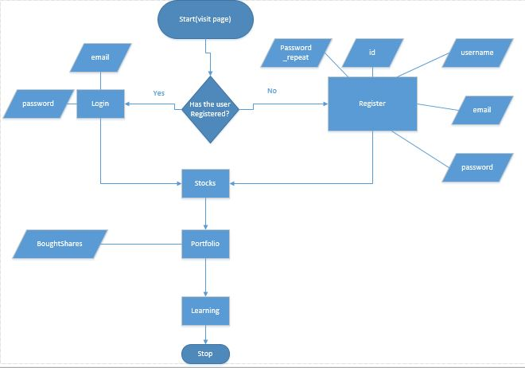

**Entity Relationship Diagram of the Database**

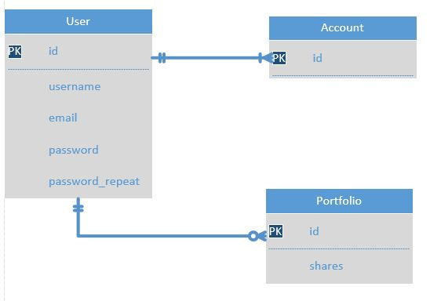

**Home Page Design**

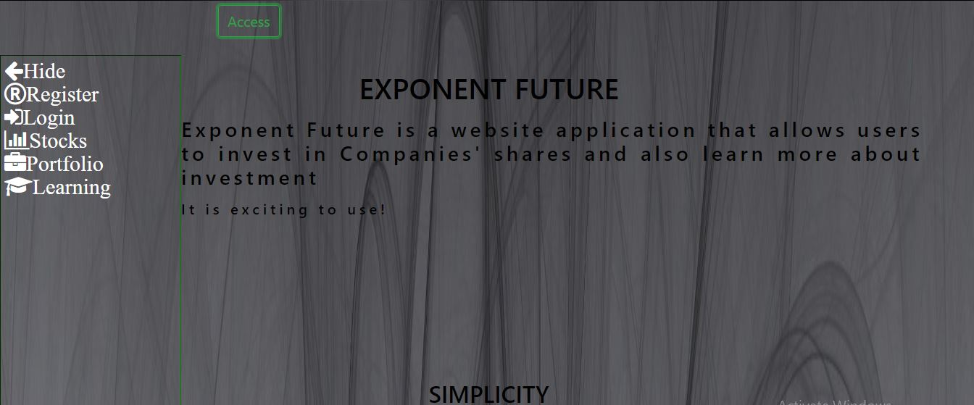

**Register Page Design**

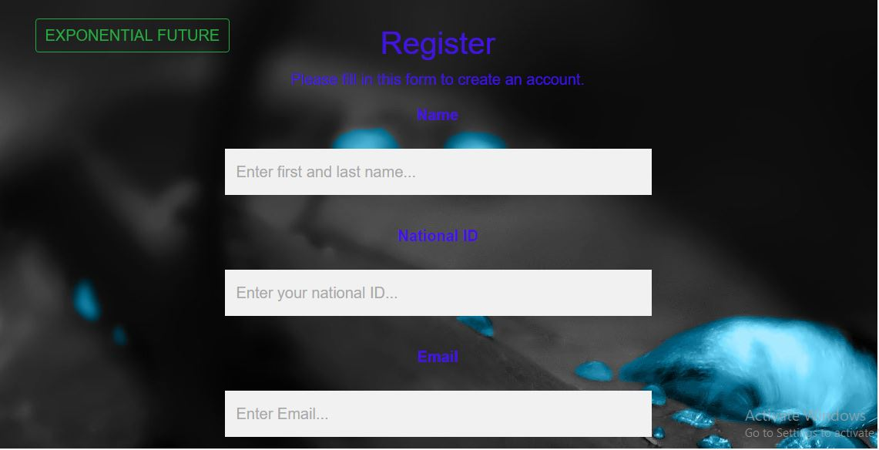

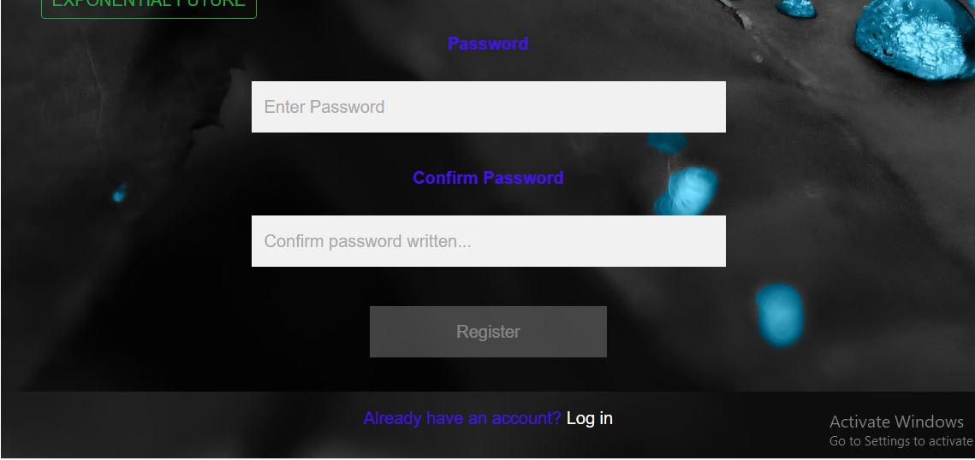

**Login Page Design**

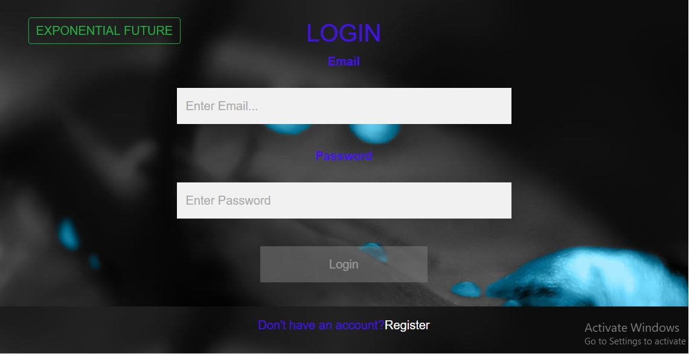

**Stocks Design**

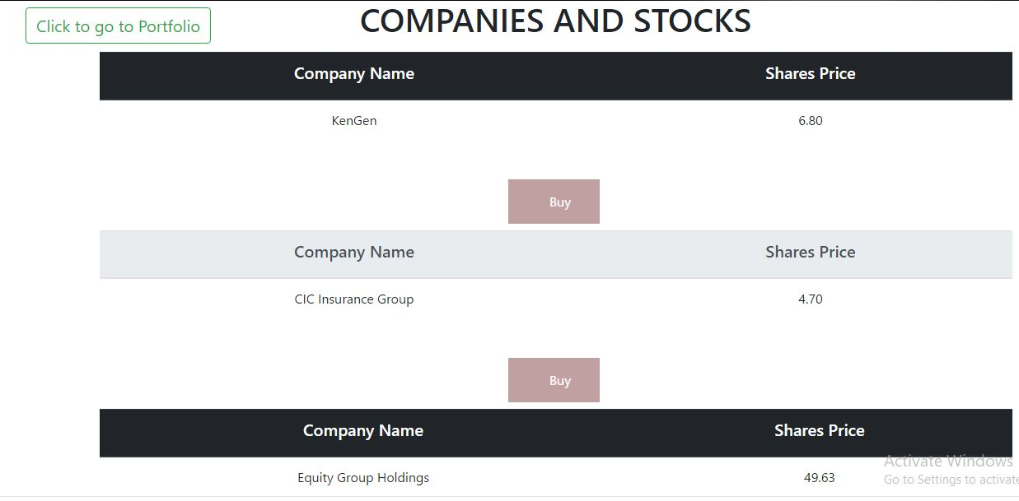

**Learning Page Design**

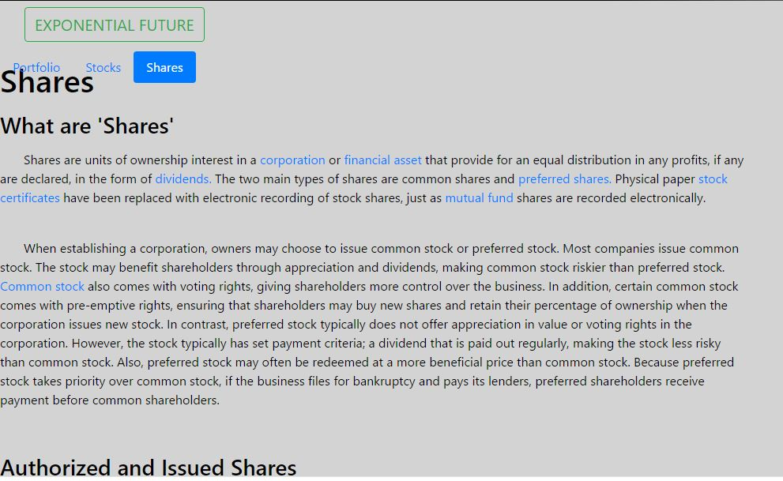

## 4.4 Module Design

Here, the detailed internal design for all the system modules is specified.

It is important that the design is compatible with the other modules in the system architecture and the other external systems

**Object Orientation**

Dividing the program into different modules so that one may work on the different modules effectively and individually.

Some principles of object orientation:

* Orientation of Program components at the real physical world. The division of a software package is done according to the real outside world of a system and according to main internal tasks of such a system.
* Combining all elements of a software into an object. This means that everything that is needed to handle an element of the system is grouped and contained in one object (encapsulation).
* Access to the object’s data functions via a clearly defined narrow interface and hiding of elements which are not required for the outside world (Data hiding)

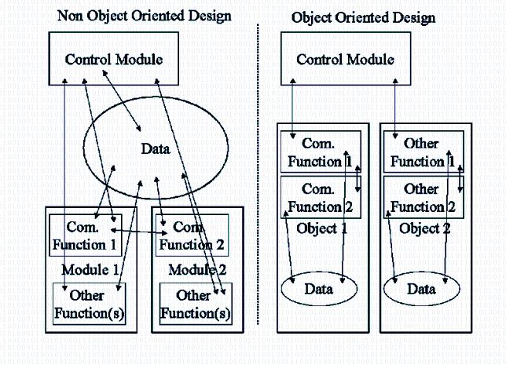

## 4.5 Coding Phase

The best suitable programming language is decided based on the system and architectural requirements.

The code goes through numerous code reviews and is optimized for best performance before the final build is checked into the repository.

The following were the coding languages and libraries used:

### 4.5.1 HTML

Used to form the skeleton of the pages and allow posting to database.

### 4.5.2 CSS

Allows enhanced beautiful look of the system.

### 4.5.3 Bootstrap

A library consisting of CSS and Javascript that gives the look and feel of the system.

### 4.5.4 Javascript

Enables clicking and responding to events. Also enables connection to database and interaction with system.

### 4.5.5 Nodejs

Is the business logic that is written in javascript format allowing interaction with user interface and database.

It also enhances authentication and unobtrusive security of database.

### 4.5.6 MongoDB

The database that stores and allows confirmation of user details.

### 4.5.7 Implementation

There will be implementation of system that will allow business activities to be carried out.

There will also be training of people on how to use the system so as to ensure consistency in database and ease of use in case of enquiry by customer.

# CHAPTER FIVE: CONCLUSIONS AND RECOMMENDATIONS

## 5.1 Degree of Success, Learning Experience

Through the process of system development, I have gained a lot of experience and significant skills.

Some areas include:

* **Time management**: I did the project within three weeks! Lots of engagement was needed and interaction with classmates.
* **Achieved goals versus Expected goals:** The achieved goals were far much less than the expected goals. This is due to insufficient skills in dealing with projects and their implementation.
* **Skills in coding:** I really gained a lot of skills in coding and catching up with the current emphasis on Javascript and Gitlab and Github. It was one of the best learning experiences ever!

## 5.2 Conclusion

I would like to conclude this documentation by stating that it explains the needed knowledge on how to maneuver through the system. For it still has some database errors.

## 5.3 Limitations

1. Time - there was little time given to complete the project.
2. Skills - there was insufficient skills possessed so as to do the project.
3. Economical resources - there was little money possessed so as to allow ease of executing the project.

## 5.4 Recommendations and future work

I recommend individuals who would like to invest in stocks to consider this concept in their future endeavors. This just outlines one of the bigger pictures needed for one to move to a place where technology is dong most of the work for people.

# REFERENCES

Shelly B. Gary, *Systems Analysis and Design*, United States of America, Course Technology, Cengage Learning, 2012

Hoover Ryan, “How to Begin Investing on the Nairobi Securities Exchange”, *Investing Africa*, September 4, 2016

Baldwin James Garrett, “Acorns: The Perfect Investing Tool for Millennials”, *Investopedia*, July 30, 2015

Indeje David, “What to Expect in 2018 For The Kenyan Economy”, *soko directory*, December 28, 2017

“The World Bank In Kenya”, *The World Bank Group*, October 10, 2017

Bourgi Sam, “E\*TRADE Review and Ratings”, *Investopedia*, January 1, 2018

“Investment Apps Like Acorns: A Detailed How-To-Create Guide”, *Cleveroad*, 8 June 2017

Pototska Iryna, “How to Build a Free Stock Trading App Like Robinhood”, *Yalantis - Mobile App Design and Development Company*, 2018

Mind Tools Content Team, “Business Requirements Analysis”, *Mind Tools*

Margaret Rouse, “technical requirements”, *TechTarget*

“Transition Requirements: The Requirements Gathering ‘Underdog’”, *Business Analyst Learnings*

“Module Design”, *The-Software-Experts*